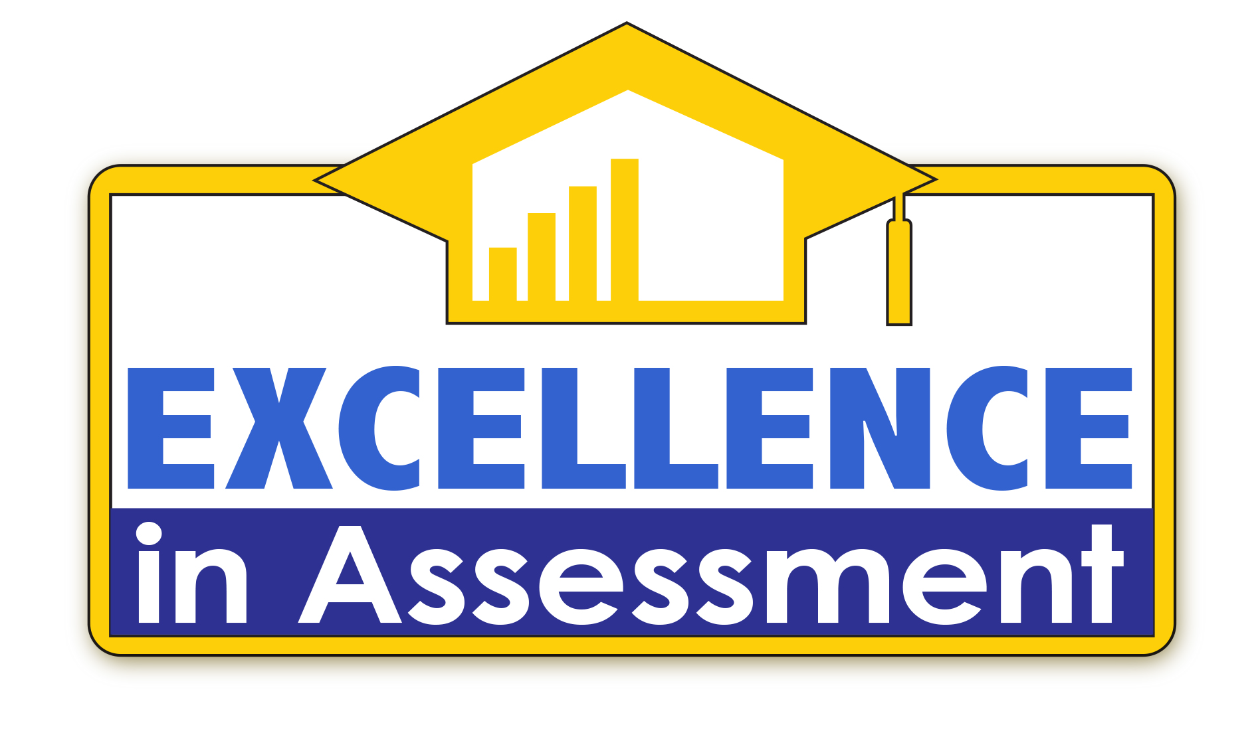

Excellence in Assessment Designation Application Packet 2021

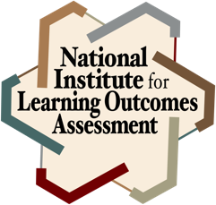
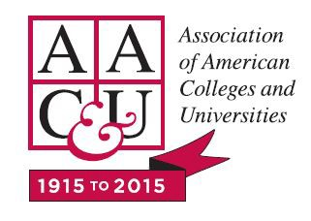
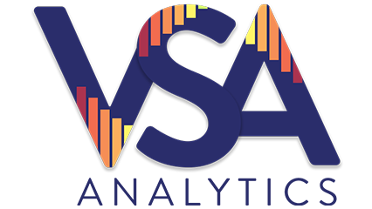

Contents

Overview 1
Application Components Overview 6
Application Contacts 8
Application Narrative Components 10
Groups and Individuals Engaged in Assessment Activities 11
NILOA Transparency Framework Components 12
Reflection and Growth/Improvement Plan 15
Scoring Overview 16
Application Process and Deadlines 17

The Excellence in Assessment Designation is co-sponsored by VSA Analytics, the National Institute for Learning Outcomes Assessment (NILOA), and the Association of American Colleges and Universities (AAC&U). EIA is endorsed by the Council of Independent Colleges (CIC).

Overview
The Excellence in Assessment (EIA) designation recognizes exemplary colleges and universities that integrate assessment practices throughout the institution, provide evidence of student learning outcomes to stakeholders, and utilize assessment results to guide institutional decision-making and improve student performance. Institutions implementing and/or sustaining comprehensive use of assessment of student learning outcomes institution-wide are eligible to receive the designation.
The EIA designations focus on institution-wide processes and use of assessment results rather than on student performance or accomplishment. While student learning outcomes are an essential component of assessment processes, they are only one of many pieces necessary to facilitate institutional growth and improvement. The EIA designation evaluation process is directly linked to the National Institute for Learning Outcomes Assessment (NILOA) Transparency Framework and builds on the foundation of student learning outcomes reporting within VSA Analytics. The Transparency Framework provides a structure to make evidence of assessment processes accessible, useful, and meaningful to audiences both on- and off-campuses. Designees are awarded in two tiers.
- Excellence Designees are institutions demonstrating strong leadership and commitment to a culture of evidence-based decision-making centered on the use of institution-level assessment results. Excellence institutions may, for example, have in place widespread program assessment but are integrating their use of student learning outcomes to inform institutional decision-making. Alternatively, Excellence institutions may already have completed most of the steps of assessing student learning at the institution-level, but are intentionally addressing gaps in the integration of their processes across academic and student affairs.
- Sustained Excellence Designees are institutions who have maintained and/or evolved their integrated institution-level student learning outcomes assessment over a period of five (5) or more years. Sustained Excellence institutions have a solid foundation and track record of integration of assessment data from across the institution and of using assessment results to guide programs and curriculum.

Through the application process for the EIA designations, institutions will identify the strengths of institution-level assessment activities as well as areas for growth and improvement. Applications are evaluated by faculty and assessment experts on eight domains regarding institution-level assessment processes:
- the diversity of groups and individuals engaged in assessment activities;
- student learning outcomes statements;
- assessment plans;
- assessment resources;
- current assessment activities;
- evidence of student learning;
- use of student learning outcomes results; and
- growth and improvement plans.

Designees receive a commemorative plaque, along with a certificate and electronic logo that can be used by the institution to demonstrate their achievement and commitment to student learning outcomes assessment. Designations will be publicly announced in August following each application cycle. Designations will be awarded for a 5-year period, e.g., designations awarded in 2021 will last until 2026. Institutions that wish to maintain their designation past the end of the award period should plan to reapply in the last year of the award period, e.g., institutions receiving the designation in 2021 should plan to submit a re-application in spring 2026 to avoid any gap.

2021 Application Timeline:
- Application materials released: September 2020
- Application deadline: May 3, 2021
- Applications notified of EMBARGOED Designation results: July 30, 2021
- Public announcement of designees: August 18, 2021
- EIA Mentoring Opportunity: Assessment Institute, October 25-27, 2020
October 24-26, 2021
- EIA Designee Reception: AAC&U Annual Meeting, January 2022

Why do we need a national designation of excellence?
One of the main goals of the EIA program is to create a national recognition for institutions that are integrating assessment practices to provide evidence of student learning outcomes that are representative of all students who attend their institution. Prior to EIA, there was no such recognition, which hinders our efforts in at least three areas.

First, there is not one right way to implement a broad and deep assessment plan for all institutions, but rather many right ways. Assessment done well is integrated throughout the work of many faculty and staff; by offering a national recognition of those institutions doing exemplary work, the EIA designations create an opportunity to reward and celebrate those efforts.

Second, by explicitly recognizing that there are many models for effective assessment of student learning, the EIA designations serve as both celebration of the work these institutions have accomplished as well as guideposts for other institutions looking to improve their own evaluation of student learning. The EIA designations are open to all accredited institutions and the goal is to identify a plethora of examples from across sectors and levels to share broadly. By actively seeking to identify those institutions who are doing this work, we will create a larger network of examples for other institutions to explore.

Third, the lack of a common, national recognition program for institutional assessment limits our ability to engage with external stakeholders and hold up concrete examples of the good assessment work in which our institutions are engaged. While still respecting the diversity of what good assessment looks like in practice, the EIA designations provide a signal for external audiences to look to.

Why institution-level assessment as a focus?
Institution-level assessment is often thought of as an accountability or accreditation concern that is somewhat removed from the work of faculty teaching in specific programs or classes. The EIA program, however, understands that institution-level assessment builds from a foundation of faculty assessment of student learning, as an integrated component designed to serve as a “tip of the iceberg” indicator for the depth and breadth of student learning happening at our institutions (see Figure 1).
Institution-level assessment does not necessarily consist of using an identical or standardized assessment instrument administered to all students but represents a broader and deeper approach to assessment that is integrated across departments, programs, and co-curricular offerings. An ideal institution-wide assessment plan would consist of aligned outcomes at the student-, course-, unit-, program-/major-, and degree-levels. Again, what that looks like for any given institution may be varied and diverse, and recognizing the multiple paths to demonstrating student learning outcomes is the goal of the EIA designation.
In this view, assessment activities occur at multiple levels where each level is related to and either builds from or supports the levels below and above it, creating a scaffold of evidence across all students and their learning. The nature and setting of assessment activities at each level may or may not be different depending on the program and institution. For example, assessment of institution-level learning outcomes may occur within the context and setting of an individual capstone course or it may occur in a separate, proctored exam.
The results of assessment at each level, however, need to be comparable across all students so results can be interpreted and used to identify the need for, and guide the implementation of, program and curricular improvements. Just as all students in an Accounting program need to pass a licensure exam to ensure that they have all learned the knowledge, skills, and abilities necessary to perform as a Certified Public Accountant, all students at an institution should be assessed with approaches that provide results comparable to each other to ensure all students have learned the core knowledge, skills, and abilities the institution has identified as necessary to earn a degree.
Ideally, scaffolding of learning outcomes occurs across courses, programs, and co-curricular experiences such that the assessment work from an individual course or learning experience can link to and inform the assessment work of a program. This scaffolding allows for fewer assessment activities to occur at higher levels of the pyramid than at lower levels—the evidence built from beneath serves to support the evidence provided at the top. This explains, in part, why a single representative sample of institution-level assessment outcomes is one way to reliably represent the learning of all students.

Figure 1: Pyramid of Integrated Institution-wide Assessment.

How does the National Institute for Learning Outcomes Assessment’s Transparency Framework fit in?
Even those institutions that are engaged in intentionally aligned assessment of student learning struggle to tell their stories to the variety of stakeholders to which they are accountable. While
most institutions now make a practice of publicly stating what their learning outcomes are, they generally share assessment findings internally, and frequently only to faculty or assessment committees. Rarely are assessment plans or rationales shared with students or alumni, much less
with external stakeholders such as employers, transfer institutions or programs who accept students for continued study, state legislators, or the public. Put another way, institutions talk about assessment to themselves when they talk about it at all.

The National Institute for Learning Outcomes Assessment (NILOA) created the Transparency Framework “to help institutions evaluate the extent to which they are making evidence of student accomplishment readily accessible and potentially useful and meaningful to various audiences.” Based on a national review of institutional assessment websites, the Transparency Framework consists of six components centered around a set of common underlying principles (see Figure 2).
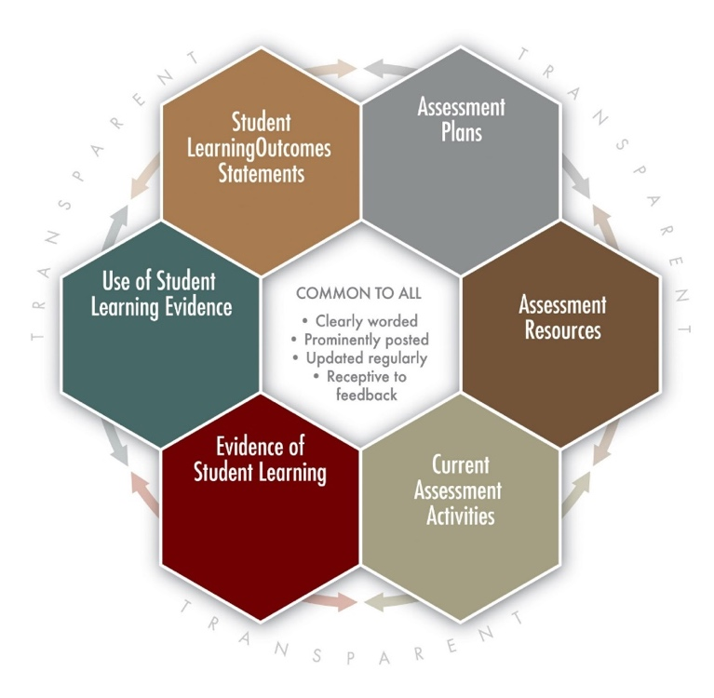
Figure 2: The National Institute for Learning Outcomes Assessment (NILOA) Transparency Framework

Conclusion
As increased attention has been paid to institution-level assessment results as an indicator for accountability, pressure to simply report results to meet external demands has intensified. In some cases, this pressure has led to decoupling institution-level assessment activities from those that support and give credence to their results. Even institutions engaged in strong student learning outcomes assessment struggle to tell their stories to stakeholders both on- and off-campus. The purpose of the EIA designations is to recognize the work of those institutions that are engaging in the full breadth and depth of vertically and horizontally integrated student learning outcomes assessment, ensuring that all systems are linked and cross-validated between and among academic and student affairs. These institutions deserve recognition of their accomplishments and by identifying them, the EIA designations also highlight them as exemplars for other institutions to explore.

Application Components Overview

Applications consist of the following components submitted electronically:
- A letter from senior leadership (e.g., President/Chancellor) stating why the institution decided to pursue the Excellence in Assessment (EIA) Designation. The letter is the introduction to your institution’s application and should be no more than two pages. The letter should provide an overview of your institution’s submission for the EIA designation, including any highlights you wish to emphasize in your application. The letter is not scored as part of the application.
- A completed institutional contacts form (see form provided as part of this packet).
- An overview of individuals and groups engaged in assessment activities across the institution, such as assessment councils or committees at college, program-, department-, and/or unit-level, with brief descriptions of the charge of each group as it relates to assessment. These individuals and groups are not required to participate in the creation of the application, but rather are intended to help reviewers better understand the structure of assessment processes and should be no more than two pages. This brief overview can also serve as a reference document within the narrative so that applicants do not have to explain the function of each group in the content of their applications. If so desired, applicants can include as an appendix an annotated list of individuals and groups involved in assessment processes and practices.
- Application narrative between 2,000 and (no more than) 3,000 words. Tables and/or figures included in the process narrative count toward the 3,000 word limit. Word count does not include Items 1 through 3 above.
  - The application narrative should be written to an audience of higher education peers who are not familiar with the applying institution’s context or assessment processes and approaches. For this reason, institutions should include an introduction to the context, philosophy, and/or history behind the assessment approach outlined within the narrative. Basic familiarity with higher education assessment, accreditation, and accountability concepts can be assumed.
  - Applications should address the eight domains described below in more depth in the Narrative Components section. Criteria 2-7 are the six components of the NILOA Transparency Framework as viewed from the perspective of institution-level/institution-wide assessment of student learning outcomes.

- Introduction
- Student Learning Outcomes Statements
- Institution-level Assessment Plan
- Institution-level Assessment Resources
- Current Institution-level Assessment Activities
- Evidence of Institution-level Student Learning
- Use of Institution-level Student Learning
- Reflection and Growth/Improvement Plan

  - It is not a requirement that each domain be given equal space; institutions should decide the best use and formatting of their application information.
  - You may include links to additional information online and/or provide appendices
as references within your narrative if you feel that the information contained within cannot be succinctly summarized or described. Reviewers will be asked to read material at web links or appendices only as noted in the Application Narrative Components. Reviewers will be required to visit no more than three links in any section.
  - Applicants should make every attempt to include all pertinent information in their narrative. Do not attach forms, templates, reports, or screenshots of information in lieu of describing the process for and functions of integrated assessment activities at your institution. The narrative element of the EIA places an emphasis on why particular processes are utilized as well as the action that results from it. The application narrative is designed to help institutions clearly and succinctly explain why they do what they do when it comes to institution-wide assessment of student learning.
  - Institutions should provide a coherent narrative addressing each of the criteria domains, clearly labeled, in their application. The overall purpose is to write a narrative of the assessment process to those not familiar with the institution or its culture. The guiding questions are strongly linked with the scoring rubric, assisting institutions in addressing the breadth and depth of their assessment activities in their response, however, every institution is not required to respond explicitly and separately to each question.

Application materials should be submitted electronically as a single document. Application items should be submitted via email to niloa@education.illinois.edu by May 3, 2021. Applications sent to other email addresses will not be considered; please submit your application to the correct email address.

This form allows us to collect contact information for key people who should be notified in case of questions regarding your institution’s application or with information regarding any public announcements that may result should your application receive an Excellence in Assessment Designation.

Primary Application Contact: Answer questions about the content of your application should reviewers need additional clarification or request additional evidence or information. The primary application contact will be notified of the results of your application, including any feedback from reviewers, by email and postal mail late July.

Name: ________________________________________________________

Title: ________________________________________________________

Email Address: ________________________________________________________

Phone Number: ________________________________________________________

Mailing Address: ________________________________________________________

________________________________________________________
________________________________________________________
Senior Leader: Provide contact information for the senior leader who submitted the letter to accompany your institution’s application. The senior leader will be notified of the results of your application, including any feedback from reviewers, by email and postal mail late July.

Name:
Title:
Email Address:
Administrative/Executive Assistant Name:
Administrative/Executive Assistant Email:
Phone Number:
Mailing Address:

Media/Public Relations/University Communications Contact: Contact regarding coordination of any press releases or other public announcements in which your institution may be mentioned should your application for an Excellence in Assessment Designation be successful. Communications with this person will begin in July only if your institution is awarded a Designation.

Name: ________________________________________________________

Title: ________________________________________________________

Email Address: ________________________________________________________

Phone Number: ________________________________________________________

Mailing Address: ________________________________________________________

________________________________________________________

________________________________________________________

Application Narrative Components
The Excellence in Assessment (EIA) program recognizes colleges and universities that integrate assessment practices across the institution, provide evidence of student learning outcomes, and use assessment results to guide institutional decision-making and improve student performance.
Each EIA application consists of a narrative response (see Application Components Overview for details on length and formatting) addressing the criteria listed below. The overall purpose is to write a coherent narrative of the assessment process to those not familiar with the institution or its culture. The scoring rubric available from the EIA website is used by reviewers to determine which applicants are eligible for the EIA designation. Institutions are strongly encouraged to engage in self-assessment using the EIA scoring rubric prior to submitting their application.
Criteria in the rubric reviews eight domains:
- Groups and Individuals Engaged in Assessment Activities
- Student Learning Outcomes Statements
- Institution-level Assessment Plan
- Institution-level Assessment Resources
- Current Institution-level Assessment Activities
- Evidence of Institution-level Student Learning
- Use of Institution-level Student Learning
- Reflection and Growth/Improvement Plan
Each domain is described in additional detail below. The guiding questions are intended to foster discussion and thoughtful dialogue among the application team to ascertain both the existence and quality of institutional assessment processes. For instance, if a policy is in place that requires programs to report annually, but those reports are rarely read or incorporated in other institution decision-making processes, it is the expectation of the EIA application process that the institution will identify concrete plans for making their processes more engaged and meaningful in their Reflection and Growth/Improvement Plan.
Reviewers noted that many institutions seemed to struggle with presenting a cohesive and concise narrative regarding their institution-level assessment process. The difficulty came from making an active shift away from simply listing processes and/or activities to focusing on explaining why the
processes in place at their institution mattered for their specific setting or students. Providing appropriate background context for assessment practices is important for reviewers and others to understand why the institution engages with and approaches assessment in the manner it does. Many institutions defaulted to providing lists of various disconnected activities without connecting or aligning the activities into a cohesive narrative and describing or explaining the relationships between the various parts. Applicants are strongly encouraged to approach the narrative as a representation of the collective whole of assessment activities, one that is placed within a specific institutional context, and to provide that context explicitly within their narrative when necessary. It is not enough to say that an institution is engaged in a particular assessment practice without articulating why that practice is important within that context. A resource to help with this is the Evidence-Based Storytelling toolkit on the NILOA website.

Groups and Individuals Engaged in Assessment Activities
Assessment should be an integrated process, involving decision-makers from all areas of the institution. The expectation for EIA designations is that groups exist at an institution charged, in whole or in part, with contributing to, participating in, overseeing, and/or making use of assessment data and reports. While a single position, office, or committee may be identified as the one responsible for completing institution-level assessment administration and collection of results, it is insufficient for a single position, office, or committee to be the sole custodian and consumer of this information.

Too often, those responsible for institution-level assessment are disconnected from other levels of
assessment. The purpose of the EIA designation is to both serve as a tool to help institutions identify the practices and policies that can be improved to help integrate assessment activities and
to recognize those institutions who have succeeded in such integration.

To demonstrate the level of institutional understanding of and commitment to integrated assessment, an EIA application should include evidence of substantive participation in assessment activities by individuals that represent a variety of roles across and off-campus:
- Senior administrative leadership, e.g., President’s or Chancellor’s cabinet members;
- Personnel/Committee responsible for the oversight of institution and program (including academic and student affairs) assessment activities;
- Personnel responsible for the oversight of institution and program accreditation activities;
- Faculty, both tenure/tenure-track and adjunct, from a variety of departments and/or representing faculty governing bodies;
- Non-instructional staff responsible for student support, such as academic and career advisors, other student service personnel, and the library;
- Students from a variety of majors and years, and/or representing student governing bodies;
- Representatives from the community or other external stakeholders in student outcomes, e.g.,:
- Alumni from a variety of majors and years, and/or representing a broad/institutional alumni group;
- Employers and/or business representatives from the community;
- Institutions who commonly accept students who have completed coursework at the applying institution, such as transfer partners, graduate schools or programs;
- Community-based organizations and/or community partners; and/or
- Members of institutional oversight or governing bodies.
These individuals and groups are not required to participate in the creation of the EIA application, but rather are intended to help reviewers better understand the structure of assessment processes at the applicant’s institution. The brief overview of the various groups and individuals serves as a reference document within the narrative so that applicants do not have to explain the function of each group in the content of their applications.

Student Learning Outcome Statements
Student learning outcome statements clearly state the expected knowledge, skills, attitudes, competencies, and/or habits of mind that students are expected to acquire at an institution. For the purposes of the EIA designation, applicants should provide evidence that student learning outcome statements are integrated with co-curricular, college-, program-, unit- and course-levels.

Guiding questions:
- Does the institution have clearly stated shared student learning outcomes?
- Are learning outcomes intentionally linked or scaffolded into program- and course-level student learning outcome statements? Co-curricular?
- Are student learning outcomes statements prominently posted and communicated to students and other stakeholders?
- Are assessments of student work in courses, programs, and co-curricular activities clearly linked to shared learning outcomes?
Institutions are strongly encouraged to include one or more links to webpages listing their student learning outcomes within their narrative. Links should be embedded in the narrative so that they contribute to the flow of evidence being presented, rather than simply listed under a section.

Institution-level Assessment Plan
Institution-level plans for gathering evidence of student learning might include institution-wide approaches that convey how student learning will be assessed, the data collection tools and approaches that will be used, and the timeline for implementation. Such plans may build on the work from program-level and unit-level plans, but should represent some level of common assessment activities designed to provide evidence of the learning throughout the institution. For the purposes of the EIA designation, applicants should provide evidence that the assessment plans across the institution are intentionally integrated or scaffolded, especially between and among academic and student affairs.

Guiding questions:
- Does the institution have a comprehensive assessment plan at the institution-level?
- Does the plan include at least some common assessment activities designed to provide evidence of student learning?
- Is the institution-level assessment plan aligned or integrated with, or scaffolded from program-level and unit-level assessment plans?
- What feedback and stakeholder involvement is there in reviewing and implementing the institution-level assessment plan?
- How are stakeholders from programs and departments—including students—involved in the development and on-going review of the plan and results?
Institutions may include one or more links to webpages describing their assessment plan to external audiences within their narrative. Links should be embedded in the narrative so that they contribute to the flow of evidence being presented, rather than simply listed under a section.

Institution-level Assessment Resources
Assessment resources encompass information or training provided to faculty, students, and staff to help them understand, develop, implement, communicate, and use evidence of student learning. Ideally, there is a centralized location where faculty and staff locate resources on assessment best practices, including information on institution-level assessment activities and how they are integrated with program, unit, and course assessment. Policy and procedures for evaluating faculty and staff include formal or official supports and/or recognition of efforts made to improve or advance assessment practices, either individually, within a program, or at the institution-level.

Guiding questions:
- Does the institution have a centralized location where faculty, students, and staff can access assessment resources?
- Are there regular faculty and staff development activities designed to promote best practices in understanding, developing, implementing, communicating and using evidence of student learning?
- Do faculty, students, and staff use the resources provided?
- How are policies and procedures regarding faculty and staff review processes structured to provide support or recognition for faculty and staff working to improve or advance their assessment practices?
Institutions are strongly encouraged to include one or more links to webpages showing resources available to faculty and staff within their narrative. Links should be embedded in the narrative so that they contribute to the flow of evidence being presented, rather than simply listed under a section.

Current Institution-level Assessment Activities
Current assessment activities include information on the full range of projects and activities recently completed or currently underway to gauge institution-level student learning, make improvements, or respond to accountability interests. Information on current assessment activities is easily accessible to various audiences both on- and off-campus, including information on how institution-level assessment activities integrate with program, unit, and course assessment. Information about current assessment activities may include schedules for when activities occur and when results are generally made available to various stakeholders. When new institution-level assessment activities are under consideration or being implemented, information regarding the decision process for determining the addition or change to previous practice is provided.

Guiding questions:
- How does the institution share information with a variety of internal and external stakeholders about current institution-level assessment activities?
- Is the provided information communicated in an easily accessible format and understandable to a variety of audiences both internal and external to the institution?
- When new institution-level assessment activities are under consideration or being implemented, how is information regarding the decision process shared? Who participates in the decision process?

Institutions are strongly encouraged to include one or more links to webpages they use to share information on institution-level assessment activities with internal and external audiences within their narrative. Links should be embedded in the narrative so that they contribute to the flow of evidence being presented, rather than simply listed under a section.

Institution-level Evidence of Student Learning
Evidence of student learning includes results of institution-level assessment activities. This may include evidence of indirect (e.g. surveys) and direct (e.g. portfolio) student learning as well as institutional performance indicators (e.g. licensure pass rate). This section should focus on how the institution connects the dots between the multiple layers of assessment activities occurring within programs, units, courses, and various learning experiences. Documentation should specifically address how data and results from multiple assessment activities align or overlap to provide an integrated picture of student learning.

Guiding questions:
- What evidence is used by the institution at various levels to provide a complete picture of student learning?
- How are institution-level results of student assessment shared with programs, units, and departments? How is access to results determined?
- What mechanisms are in place to facilitate conversations across or among various groups collecting evidence of student learning?
- Who is engaged in the process of collecting, reviewing, monitoring and compiling evidence of student learning?

Institutions are strongly encouraged to include one or more links to webpages they use to share outcomes from institution-level assessment activities with internal and external audiences within their narrative. Links should be embedded in the narrative so that they contribute to the flow of evidence being presented, rather than simply listed under a section.

Use of Institution-level Student Learning Evidence
This component represents the extent to which institution-level evidence of student learning is used to identify areas where changes in policies and practices may lead to improvement, inform institutional decision-making, problem identification, planning, goal setting, faculty development, course revision, program review, and accountability or accreditation self-study. Institutions should use evidence from multiple levels to guide programmatic and curricular decision-making as well as monitor and evaluate the results of those decisions for improvements in learning. The assessment cycle should allow for sufficient time between the introduction of changes or new programs for implementation to stabilize and results to be known with some certainty (e.g., poor initial results should not automatically result in abandonment; conversely, positive initial results should not automatically result in widespread adoption without further verification and discussion).

Guiding questions:
- What evidence does the institution provide to stakeholders internal and external to the institution that their institution-level assessment activities are incorporated in institutional decision-making?
- What spaces exist for various stakeholders to come together to make sense of and
determine what to do, if anything, with assessment results from multiple levels within the institution?
- How are institution-level assessment results available in ways that integrate with results from other levels of assessment activities (i.e., academic and student affairs data integration)?
- How are the uses of assessment results shared with various audiences?
- Who participates in the monitoring and evaluation of decisions to ensure they bring about the desired change(s)?
Institutions are strongly encouraged to include one or more links to webpages describing how assessment results are used on their institution within their narrative. Links should be embedded in the narrative so that they contribute to the flow of evidence being presented, rather than simply listed under a section.

Reflection and Growth Improvement Plan
Even institutions that excel at using assessment results to inform and guide their decision-making have room for improvement. The final narrative component of the EIA application should focus on revelations made by your application team in the process of completing your application, reflecting on the overall quality and robustness of your institutional assessment system and use of assessment data, and the identification of concrete steps you plan to take in the next three years to grow or improve your institutional use or integration of institutional assessment results. (Note that institutions that successfully receive the EIA designation and choose to reapply at the end of their initial designation period will be expected to reflect on the success of their efforts in their reapplication.)

Guiding questions:
- What were the biggest surprises or revelations made by your application team in completing your EIA application?
- Was there anything you expected to find but didn’t?
- Where are your institution’s greatest strengths?
- What are some of your largest or most important challenges?
- How are you planning to grow or improve your institutional use or integration of institutional assessment results or data use?
- What concrete steps will your institution engage in to accomplish your plans?
- What resources will you use to help you achieve your plans?

A panel of assessment experts from around the country will review and score each institutional application. At least two reviewers read each submission. Reviewers use the scoring rubric available on the EIA website to evaluate submissions.
The rubric scoring is based off of evidence provided in the institutional application narrative. Applications are reviewed holistically prior to scoring by expert reviewers. The minimum score for consideration of being awarded an EIA designation is 72, however meeting the minimum overall score does not guarantee receipt of a designation. Reviewer recommendations will be taken into consideration and the final decision will be made in consultation with the reviewers and staff of the sponsoring groups and associations.

Following individual scoring of the rubric, reviewers collectively discuss the application and make an overall recommendation for whether the institution should receive an Excellence in Assessment Designation. Institutions who are recommended for a Designation will then be considered by the reviewers for the Sustained designation based on whether evidence was provided that the institution has been engaged in meaningful institution-wide assessment practices for at least the last five years. In other words, Sustained designations are determined holistically after all other criteria have been rated.
Each application is reviewed on the basis of its own merits and is not considered in comparison to other applications received or reviewed. There is neither a minimum nor a maximum number of EIA Designations that may be made in a given year.

The EIA evaluation rubric is available in an Excel file from the EIA website.

Eligibility to Apply
Institutions applying for an EIA designation must be degree-granting, accredited institutions. Schools within colleges are not eligible to apply.

Application Submission Deadlines for 2021 designation
- Submission of completed EIA Application: May 3, 2021
- Applicants Notified of EMBARGOED Designation Results: July 30, 2021
- Public Announcement of Designees: August 18, 2021

2021 Application Process & Key Dates
There is one EIA application cycle annually.

Compile and submit a completed EIA Application by May 3. The component definitions and guiding questions for the EIA designation review criteria have been adapted to an application review rubric, available here: https://www.learningoutcomesassessment.org/eia/
Institutions are encouraged to engage in self-assessment using the application review rubric prior to submitting their application.
  - Applications should be submitted electronically to niloa@education.illinois.edu
  - Application materials will be viewed by staff of the sponsoring groups and associations and shared with EIA application reviewers identified by the sponsoring groups and associations for the purpose of completing the application evaluation. Institutions will be identified by name to EIA application reviewers, though reviewers will be restricted from identifying which institutions they review or the details or results of their review with anyone but staff of the sponsoring groups and associations.
- Notification of EIA Designation to Institutions by July 30. All applicants will be notified of the results of their designation application individually by email to their senior leader and primary application contact person.
  - Feedback from application reviewers will be shared with all applicants, regardless of designation status, though individual reviewers will not be identified.
  - Institutions will be asked not to publicly announce their designation status until the official announcement date, though feedback from the application reviewers can be shared with members of the institution. Institutions may release EMBARGOED notification of their status to media up to 5 days before the public announcement.
- Official Announcement of EIA Designation Recipients by Sponsoring Groups & Associations by August 18. An official press release announcement will be made by the sponsoring groups and associations to announce recipients of the EIA designation. Only institutions who successfully received the designation will be listed in the announcement. Plaques and certificates will be awarded at the AAC&U Annual Meeting, held annually in January.

Kuh, G. D., Jankowski, N., Ikenberry, S. O., & Kinzie, J. (2014). Knowing what students know and can do: The current state of student learning outcomes assessment in US colleges and universities. Urbana, IL: University of Illinois and Indiana University, National Institute for Learning Outcomes Assessment (NILOA).
Kuh, G. D., Jankowski, N., Ikenberry, S. O., & Kinzie, J. (2014). Knowing what students know and can do: The current state of student learning outcomes assessment in US colleges and universities. Urbana, IL: University of Illinois and Indiana University, National Institute for Learning Outcomes Assessment (NILOA).
National Institute for Learning Outcomes Assessment. (2011). Transparency Framework. Urbana, IL: University of Illinois and Indiana University. Retrieved from: https://www.learningoutcomesassessment.org/ourwork/transparency-framework/

