Macintosh HD:Users:victoriawallace:Dropbox (Partners HealthCare):LARC_Learning Assessment Research Consortium:CREATIVE COMMONS IMAGE.png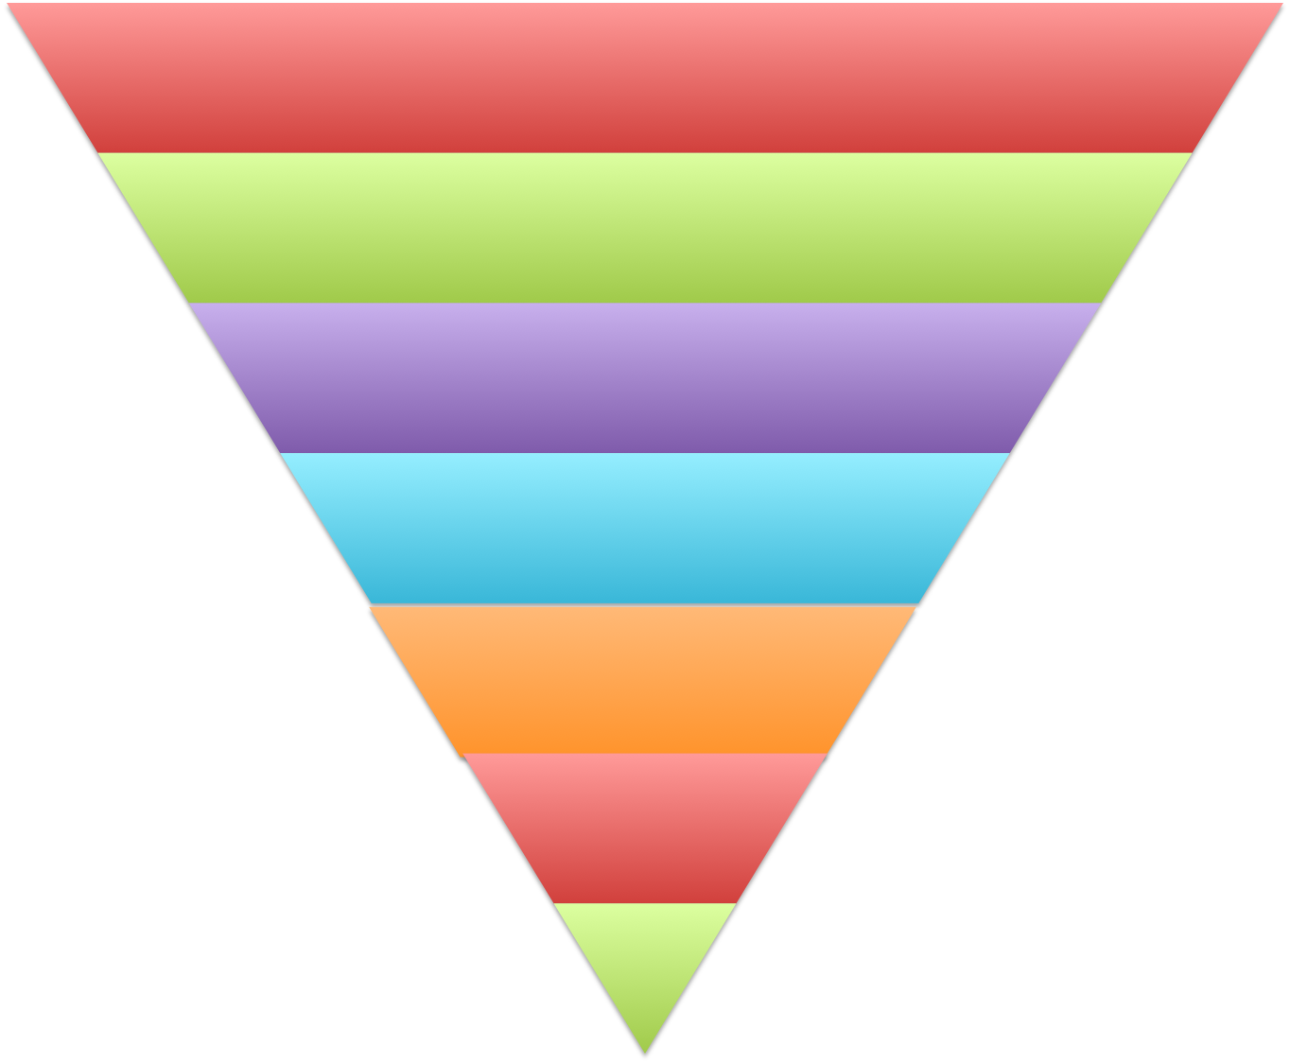

**Institutional Level:**

**School/College Level:**

**Program Level 1:**

**Program Level 2:**

**Program Level 3 (measurement):**

**Course Level 1:**

**Course Level 2 (measurement):**

Examples:

**Course Level 2 (measurement):**

Learning Objectives,

Learning Outcomes, etc.

**Program Level 3 (measurement):**

Outcome, Results, etc.

**Course Level 1:**

Course Goals, Course Outcomes,

Course Objectives, etc.

**Program Level 1:**

Mission, Charge, Aim, Purpose, etc.

**Institutional Level:**

Mission, Charge, Aim, Purpose, etc.

**School/College Level:**

Mission, Charge, Aim, Purpose, etc.

**Program Level 2:**

Goal, Objective, Target, etc.