Goals and Objectives
Activities
- Introduction and Objectives
- How are Goals and Objectives Defined?
  - Warm Up Activity
Write down the questions you are trying to answer about the assessment process. These questions might be about student learning, student engagement, course assessment, program assessment, institutional effectiveness, or other areas of interest. These questions will inform the process you use to decide what data to gather and how you gather it.
- I’m a language and literature professor. In terms of my language courses, I’m always trying to assess how students perform according to national benchmarks for proficiency in different skill sets (reading, listening, writing, speaking, cultural understanding). For the literary courses, my aim is to provide critical thinking skills so that students can confront materials and analyze them to draw conclusions, comparisons, and insights.
  - Activity: What terminology do you use?
This inverted pyramid is meant to convey an institution's hierarchical alignment (a connection/relationship) between statements of intentionality; its broad mission and goals with program and course goals & outcomes and specific learning objectives.
Considering your own institutional context, decide which terms are most appropriate in your hierarchal structure and add them to the blank inverted pyramid in Institutional Alignment Handout (PDF).
Institutional Level | Mission
School/College Level | Not sure
Program Level 1 | Not sure
Program Level 2 | Goals
Program Level 3 | Outcomes
Course Level 1 | Course Goals
Course Level 2 | Learning outcomes
Using the terms in your hierarchal structure - goals, objectives, outcomes, etc., how would you describe the hierarchy for your college or university?
- I would describe the hierarchy as a blend of top-down (mandated by the administration) and bottom-up (coming from the faculty).
Question:
Now that you have identified your institutional hierarchy, consider how your institutional goals align with the institutional mission. Can you articulate the relationship?
- Simmons College has always had a strong mission of blending the liberal arts with professional training. I believe that the work we do at the departmental level contributes to this overall goal by emphasizing critical thinking but showing how it is relevant to the workplace.

- What are Goals and Objectives?
a. Warm Up Activity
Take a moment to reflect on the importance of looking at the “big picture” before focusing on the details. Consider the following questions:
- Have you, when planning any event, focused on the details before considering the big picture? What hurdles did this approach present?
- Yes, when planning a trip abroad, for instance, I tend to get all of the details for accommodations and eating, but forget that visiting too many places in one trip might not be the most pleasurable. I tend to forget how difficult it is to go from one place to the next.
- Starting with the big picture, what do you want your students to remember about your institution, your program, or your course upon completion?
    - I want my students to become life-long learners; I want them to possess the tools to understand different cultures from their own; and I want them to be critical thinkers.

b. Activity: Your institutional goals
Considering your own institutional context, review your institutional mission and vision statements. Does your institution have goals or competencies defined and published? If not, can you use your institutional mission to state the goals? Record your institutional goals and/or competencies in the Institutional Alignment Handout (PDF).
    - Overall Mission: Linking passion with lifelong purpose to help you achieve a successful career.
    - Student Learning Goals as defined by the institution:
- Master the skills and content of their discipline
- Discover, evaluate, and apply information
- Communicate with clarity and persuasiveness
- Collaborate well with others while demonstrating leadership skills
- Demonstrate ethical responsibility and commitment to a diverse, inclusive community
- Integrate learning with their lives and aspirations

How does your program align with the institutional goals?
    - Our goal in our program is for students to become proficient in another language. We show them how to use their language skills in the workplace and how to analyze cultural documents. In this regard, our goals align well with institutional goals.

c. Activity: Find your program goals

Revisit the Institutional Alignment Handout (PDF). Fill in the Program Goals section on your inverted pyramid with your program goals.
- As a student becomes familiar with a particular language, she develops an understanding of the nature of language in general.
- By studying literary works in the original language, a student acquires an ability to read with enjoyment and full comprehension. She also develops knowledge of the intellectual and social history of the people who speak the language.
- Moreover, the knowledge and experience obtained in the critical reading of the major works of foreign literature permanently extend the range of a student's resources in the humanities and provide a means and taste for developing them further.
Questions:
As you fill in the pyramid with your program goals, consider these questions:
- Can these statements be rewritten as intended goals for your program graduates? YES
- Are these statements in alignment with your institutional and program missions? YES
- Can you start each of your statements with “upon completion of this program, students will understand (or know)"? YES
If you answered yes to all of the above, you are on your way to articulating your intended goals. If not, edit the statements, as needed.
d. Activity: Find your program outcomes
Revisit the Institutional Alignment Handout (PDF). Fill in the pyramid with your program outcomes.
- Through the Major in French at Simmons College, students who apply themselves to their studies will be able to:
- Language
a. Use the French language at the B2 proficiency level according to D.E.L.F standards (Diplôme d’études en langue française.)
b. Communicate orally in different language registers; express ideas and arguments in class presentations and class discussion.
c. Listen and discuss with others relevant topics, understand and respond to questions about class materials.
d. Write well- organized papers or reports, which include a thesis and critical analysis of key passages.
e. Read complex texts being able to identify main topics and analyze key parts of them.
- Literature
a. Study main authors and works in the Francophone literary tradition.
b. Be able to know and recognize rhetorical figures, styles and genres.
c. Be able to do research about specific issues within each literary context using appropriate bibliography and correct format according to discipline standards.
- Culture
a. Recognize and discuss cultural concepts and traditions in the Francophone world.
b. Compare different cultural and historical events with their own culture.
c. Be able to do research about specific cultural and/or historical issues using appropriate bibliography and correct format according to discipline standards.
Question: Are the program outcomes in alignment with your institutional and program missions, and your program goals? YES

e. Activity: Find your course goals and outcomes

Revisit the Institutional Alignment Handout (PDF). Fill in the course goals section on your inverted pyramid.

Learning Outcomes for FREN 311: Contemporary Issues in France
- To learn and use vocabulary related to contemporary issues in France in the fields of politics, economics, and sociology.
- To gain a better understanding of French institutions, such as the school system and the political system.
- To read and interpret data from sociological surveys in French.
- To read French articles from major newspapers and magazines.
- To listen to the French news and to be able to understand the most important ideas in a newscast.
- To watch and discuss four films: L’Auberge espagnole, Entre les murs, Au-delà de la haine, La Haine.
- To study the issues being debated in France at this moment.
- To write three papers (4-5 pages) exploring one of the topics treated in class. These papers will have a research component.
- To give three oral presentations based on your essays.
- To become aware of news sources outside of the United States so as to become a better informed citizen.
Questions:
- Are the course goals in alignment with your institutional and program missions, your program goals, and program objectives/outcomes? YES
- Are the course outcomes in alignment with your course goals? YES

f. Final Reflections
Defining, revising, and revisiting goals and objectives can be very powerful. Write a short paragraph reflecting on your journey to better understanding goals and objectives. Consider the following questions:
- Did you find it difficult to clearly articulate goals and objectives?
- Was it difficult to understand the differences between goals and objectives?
- How can you share the information you have learned today to better improve assessment processes?
Overall, I did not have difficulty articulating goals and objectives. We have done a lot of work in our institution through training and workshops to articulate goals and objectives.

- What are the Benefits of Having Course Goals, Outcomes, and Learning Objectives?
  - Warm up activity
Write as many benefits to having defined course goals & outcomes and learning objectives as you can think of in 30 seconds.
- Students know what to expect
- Drives the design of each lesson
- Helps to define assignments and rubrics
- Shows students how their learning is integrated into a higher hierarchy
- Helps with accreditation
Were you able to come up with more than five? Are these benefits things you have experienced or just read about?
- I have had first-hand experience with the statements. For instance, I do backward design from the goals to the outcomes to assignments and rubrics.
  - Activity: Reflecting on Shared Experiences
After watching the video, write reflective responses to, or with colleagues discuss the following questions:
- What were some of the key themes that you heard/saw in the videos?
- LO are important to know what you are doing
- They are important to students
- They help with accreditation
- They place learning at the center of the conversation
- Which benefits on your list were also mentioned by the faculty and administrators in the video?
- All of them
- Which benefits mentioned in your video were not on your initial list? Did these benefits surprise you? If so, why?
- Placing learning at the center of the conversation. It didn’t surprise me, but it makes sense that learning should be at the center of what we are doing.
- What differences did you notice in how the different types of positions (director of assessment, chair, and faculty member) communicated benefits from goals and learning outcomes? How did they use outcomes similarly or differently?
- Faculty members tend to think about their specific courses; Administrators tend to have a more overarching view; Directors tend to think about the purpose of the whole educational experience in their program; Chairs seem to be concerned with program accreditation and sequencing.
If you have generated additional ideas after watching and reflecting on the video, please add them to your initial list from the warm up exercise.
  - Activity: How Learning Objectives/Outcomes Benefit Different Roles

Who Benefits?
Learning objectives/outcomes are beneficial at several levels to many different people. How would learning objectives benefit (faculty/department chairs/administration) at the (course/program/institutional) level?
To begin, pick three cells where different levels intersect with different audiences. In each cell chosen, brainstorm what benefits are realized by utilizing learning objectives/outcomes to structure a course, program, or institution-level initiative. Record your answers in the appropriate cells.
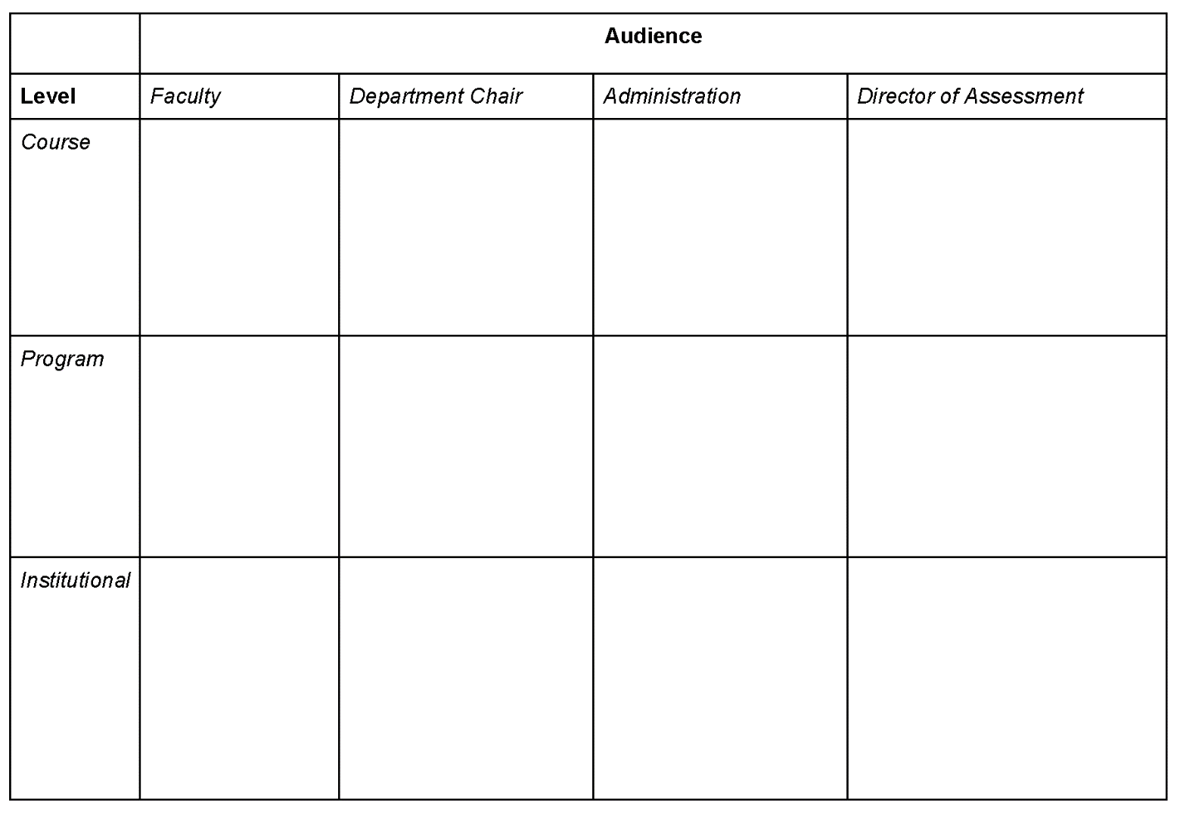
Can articulate an overall philosophy of learning for the institution.
Helps with accreditation and consistency. Helps to evaluate the efficacy of programs.
Allows to tell students what they will get out of their education. Ensures alignment with the market and other institutions. Helps measure student success.
Helps in accreditation and alignment with institutional mission. Helps measure student success.
Can articulate how the major/program is relevant to the overall goals of the institution.
Helps in accreditation and program review. Helps identify gaps in the curriculum.
Knows how the course fits into an overall institutional mission.
Knows how the course fits into an overall program. Helps drive curricular changes at the micro level.
Allows for consistency across all disciplines and schools. Focuses on student learning.
Helps to integrate courses into the overall mission of the institution.
Understands how courses fit in the overall program goals and can help drive curricular decisions.
Allows for clear guidelines in the design of lesson plans, activities, and assessment.
Next, cross-check your matrix with some of our thoughts in the sample provided.
What similarities do you see?
- What differences do you see?
      - In your answers, more emphasis was put on assessment and measuring outcomes.
- How has this exercise made you think differently about learning objectives/outcomes?
      - Somewhat. I understand know that learning objectives/outcomes are embedded in larger units.

  - Final Reflections
Return to your Warm Up Activity page where you recorded ‘benefits’ to learning objectives. Now that you have spent more time thinking about how learning objectives can improve assessment, what are some additional realizations?
Name one action you can do to facilitate to improve the development and implementation of learning objectives.
    - I could set up a meeting with colleagues in the same discipline to compare our course Los and see if they are aligned with our program goals.

- How are Goals and Learning Objectives Created?
  - Warm-up activity
Do you remember how to tell the difference between a goal and an objective? There are clear differences and it is very important to understand this before you begin writing. Take a minute to review this table and compare your goals and objectives.
Do you notice any discrepancies? Do you need to re-work some of your learning objectives? Do the learning objectives clearly connect with at least one goal? Don’t worry if you need to make some adjustments but are unclear how. We will walk through the necessary steps during this module.
  - Activity: Create a goal statement for your program or course

- Compare different cultural and historical events from the Francophone world with their own culture.
Pick one of the approaches from the previous page. Consider these questions as you draft your statement:
- In what ways do I want students to be changed as a result of my program/course?
- What abilities do I want students to have as a result of my program/course?
- What perspectives, ideas and information do I want students to be able to use as a result of my program/course?
- How will my students be able to communicate what they have learned as a result of my program/course?
- In what ways will this program/course change students’ behavior as members of their communities?
Once you have written your goal statement, use this checklist to cross-check your work:
Questions:
Are your goals…
● Broad and state general intentions?
● Consistent with your description?
● Reflecting successful student performance/behaviors?
● Aligned with accrediting agency competencies?
  - Activity: create learning objectives

- Learning Objectives for a French Cinema Course
Students [A] enrolled in the French Cinema course [C] will be able to:
  - Identify characteristics [B] of major historical developments in French Cinema, including the birth of cinema in the 1890s [D], the “réalisme poétique” of the 1930s [D], and La Nouvelle Vague of the 1960s [D].
  - Apply technical vocabulary [B] to analyze a specific scene from a French film [D].
  - Write a comparison [B] between a literary text and its cinematographic adaptation [D].
Draft 3 learning objectives for a course. Identify in each statement the 4 components required in a learning outcome statement: audience, behavior, condition, and degree.
Drafting complete learning objectives takes more time than most initially think. With experience and practice, drafting complete statements does become easier.
  - Final reflection
After completing the activities, reflect on your final product by responding to the questions below. You can do this exercise through either individual reflective writing or discussion with a partner.
- Did you find it difficult to write a complete learning objective with all 4 components? I think D is the most difficult because it asks to be very specific.
- Did you find particular components you historically (unintentionally) leave out? Can you see the value in including them moving forward? Yes, I usually leave out D. I have to think more about the details.

- How Do I Know If My Learning Objectives are Appropriate?
  - Warm up activity
Review this list of common issues and concerns related to learning objectives. Which ones resonate most with you?
- How do I know if I have enough verbs or the right verbs in my learning objective?
- From what perspective should the learning objective be written? Since I am writing them, shouldn’t they be from the faculty perspective?
- How do I know if my learning objective is measurable and observable?
- How can I identify the acceptable level of performance of my students?
- Is the learning objective student-centered rather than teaching-centered? Does the statement describe what a student will DO?
As you continue reading, we will identify ways these issues can be addressed.
  - Final reflection

After completing the activity, review your own learning objectives. Use the learning objective checklist for each statement. How well did you do? Consider working through this checklist with a colleague and exchanging learning objectives for review purposes.

- Learning Objectives at the Course Level and Outcomes at the Program Level
  - Warm-up activity
Before you begin thinking about the relationship between the learning objectives at the course, program, and course level for your particular college or university, consider how other institutions have approached alignment for the purpose of increasing student learning. Select one or more of the links below. Does the approach of any of these institutions mirror the approach you would consider taking or is there a combination of these approaches that would be more appropriate for your needs?
Linking institutional and program goals
Assessment essentials for tribal colleges
Mapping learning outcomes - Contra Costa Community College
Levels of assessment - AAC&U
After you have explored one or more of the above sites, jot down one takeaway that you think should be considered as you focus on developing goals and objectives that are in alignment with your university/college mission and program and course goals and objectives.
- My takeaway is that not all courses and programs need to fit into ALL of the institution’s mission.
  - Activity: Writing goals and outcomes for the course, program, and institution

Using the chart provided, identify which of the following statements could be written as a University Mission, a Program Goal, a Program Outcome, a Course Goal, a Learning Objective by inserting one of the following statements into the chart.
- Students learn about the process of identifying real-world ethical problems.  - Students understand how deeply held beliefs may hinder ethical decision-making.  - Seeks to develop ethical and responsible leaders committed to . . .  - Apply a solution to problem X from 3 different perspectives.  - Identify and acknowledge one’s own beliefs and assumptions | 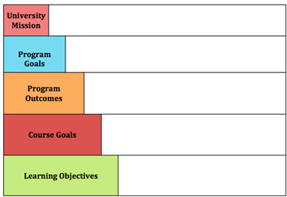  Apply a solution to problem X from 3 different perspectives.  Students understand how deeply held beliefs may hinder ethical decision-making.  Identify and acknowledge one’s own beliefs and assumptions  Students learn about the process of identifying real-world ethical problems.  Seeks to develop ethical and responsible leaders committed to . . .

- I had difficulty differentiating between Course Goals and Program Goals in this particular exercise.

  - Activity: Writing goals and outcomes for the course, program, and institution

- Institutional Level Goals and Objectives. Locate the mission statement of your College or University. Choose one goal and one of its outcomes. If there is no clearly stated goal, choose a phrase that suggests a learning goal and rewrite it as a goal. If there is no clear generalized outcome for the goal you chose (or wrote), articulate a generalized outcome for the graduates of your institution.
- Insert the institutional goal and outcome on the attached form.
- Programmatic Level Learning Goals and Objectives. Locate the associated goal and outcome in your program. If there is no associated goal or outcome, create your own (see instructions for creating goals and outcomes above). If there is an associated goal and outcome at the program level, rewrite it to align with the guidelines for writing goals and objectives above.
- Insert the program goal and learning objective on the attached form.
- Course Level Learning Goals and Objectives. Locate the course(s) in your program where these goals and outcomes exists. If there is not associated goal or outcome, create your own. If there is an associated goal and outcome at the course level, rewrite it to align with the guidelines for writing goals and outcomes.
- Insert the program goal and learning objective on the attached form.
NOTE: Ideally, this activity would be done within your department as you continue to articulate your goals and objectives.
University Mission | Demonstrate ethical responsibility and commitment to a diverse, inclusive community.
Program Goals | Students develop knowledge of the intellectual and social history of the people who speak the language.
Program Outcomes | Compare different cultural and historical events of the Francophone world with the own cultures.
Course Goals | FREN 310: Contemporary Issues in France  To explore issues faced by French society today, such as educational policies, immigration, feminism, multiculturalism, and the French political system.
Learning Objectives | To read news sources outside of the United States so as to become a better informed citizen.

Download Activity Worksheet (PDF)
  - Final Reflection
After completing the activities, consider the following questions. You can do this exercise through either individual reflective writing or discussion with a partner.
Were you able to see a clear alignment? If not, consider who, on your campus, is responsible for embedding alignment into the assessment process.
- I was able to see a clear alignment.
How would you convince the stakeholders that alignment is integral to the process of assessment?
- Practical reasons: it’s good for accreditation
- Ethical reasons: we owe it to our students for their learning process
- Collegial: We are in this together
- Purpose: Student-centered (after all, we are here so that our students can learn and be successful).

- Conclusion & Resources
  - Reflection
Reflect and respond to the questions below. You can do this exercise through either individual reflective writing or discussion with a partner.
- How are goals and objectives defined at your institution?
- The Provost Office actively engages in assessment.
- There is an Assessment Committee that helps with this issue.
- The CET (Center for Excellence in Teaching) conducts workshops and lectures to improve assessment practices.
- Individual departments work on assessment periodically.
- Why is it important to have clear learning goals & objectives?
- It gives direction to the whole institution.
- It is important for students to understand why they are learning certain skills.
- It helps guide the curriculum.
- What would you say is the most important goal for graduates of your University?
- To integrate learning with their lives and aspirations.
- How might you use your hierarchy to review and revise your institution’s goals and objectives/outcomes?
- The Provost Office
- Assessment Committee
- Why is it important to align course, program and institutional goals and objectives?
- It provides integrity to the whole learning process in the institution.
- Are your goals stated in broad terms and your objectives specific and measurable?
- Yes.
- Which stakeholders can you engage with to acquire the necessary information?
- Other Faculty members.
- Assessment Committee
- National bodies, such as ACTFL for language learning.
- Does your department(s) report into accrediting agencies? How much are you able to change based on their approval system?
- Yes. We implement changes according to NEASC standards.
- Do you need to submit changes to an institutional committee for approval?
- The Curriculum Committee oversees any curricular changes.

